

**BA 385T – Financial Management – Accounting Portion – Fall 2023**

**Instructor – Brian Lendecky (**[**Brian.Lendecky@mccombs.utexas.edu**](mailto:Brian.Lendecky@mccombs.utexas.edu)**)**

**copyright © 2023 Brian Lendecky (DISTRIBUTION IN ANY FORM IS PROHIBITED)**

**Class #2 and #3 – Wednesday August 23 and Monday August 28**

**Topic #2 – Decision Making and Relevant Information**

**This packet of class notes is copyrighted and created for the exclusive use in classes at The McCombs School of Business.** Any copying or distribution of this packet (electronically or hard copy) is a violation of federal law and will result in disciplinary actions being taken against the student.  Additionally, the sharing, uploading, downloading, and/or distribution of this packet (including, but not limited to, Slack, Chegg, Course Hero, social media sites, etc.) is a violation of the University's Student Honor Code and an act of academic dishonesty, which will result in further disciplinary action. This above also applies to McCombs students who download this material *from* Chegg, Course Hero, Slack, social media sites, etc. The following quote is from Chegg (Course Hero & other sites have similar policies): *“If you have concerns that students may be using our products inappropriately, Chegg is here to work with you and address your concerns. We will cooperate with any investigation by an academic instruction.”* I frequent Chegg, Course Hero, and other similar sites. I will and have contacted these sites in the past and they have been cooperative in providing me the name of students who downloaded and/or uploaded my material, which I then used to file McCombs academic dishonesty grievances. IT’S NOT WORTH IT! ALL acts of academic dishonesty receive significant penalties and are reported to Student Judicial Services and attach to your record.

**Relevant Costs and Revenues**

When making a decision you need to determine which information (example – revenues/benefits and expenses/costs) is relevant and which is irrelevant. In order for a piece of information to be relevant it must meet two criteria:

1. Bearing on the future

Sunk Costs – past costs that have already been incurred. They are Irrelevant in decision making because the amounts cannot be changed by any of the alternatives. Therefore, they have no bearing on the future.

To acknowledge the sunk cost, we need to agree to the fact that we made a mistake.

<https://www.youtube.com/watch?v=DDIsR4J1jh4>

Key note:

Relevant information must involve costs and benefits to be realized in the *future*. Therefore past/historical/sunk costs may be helpful as a basis for making *predictions*, however past costs themselves are always irrelevant when making decisions.

2. Differs among the alternatives

Opportunity Costs – cost or benefit of a forgone alternative. Very relevant

Because of limited resources, companies must frequently pass up profitable projects or alternatives. The profit or benefit forgone becomes an opportunity cost (even though it doesn’t show up anywhere on a financial statement) and such costs are relevant in decision making.

Two pieces of advice for decision making…

1. Avoid making the VERY false assumption that all variable costs are relevant and all fixed costs are irrelevant.

2. Make all calculations on a “total” revenue and cost basis; not a “per unit” revenue and cost basis. Just trust me on this one. (Per unit fixed costs change with changes in units, however total fixed costs do not. This is usually the cause of errors when students make calculations on a “per unit” basis.)

**Woman forced to spend 'nonrefundable' 2-week vacation with ex-boyfriend: Don't 'book vacations with bfs too far in advance'**

**Emerald Pellot - Yahoo Life -** June 17, 2022

Sometimes you just can’t shake your ex. It can seem like fate keeps bringing you back together — for better or worse.

[TikToker](https://www.intheknow.com/tag/tiktok/?utm_source=internallinks&utm_medium=internallinks&utm_campaign=internallinkstiktok) @[sadgirlhours3344](https://www.tiktok.com/@sadgirlhours3344) revealed she was forced to spend two weeks on vacation with her ex-boyfriend. The pair expected they would still be an item when the vacation came around. But the duo split and couldn’t cancel the trip.

“When you break up, but the trip was nonrefundable,” the video caption read. She and her boyfriend were lounging on the sand at the beach next to one another. Things looked awkward, to say the least.

The [viral video](https://www.intheknow.com/culture/trending/?utm_source=internallinks&utm_medium=internallinks&utm_campaign=internallinkstrending) racked up 12.7 million views and 2.5 million likes. Fortunately, the [TikToker](https://www.intheknow.com/tag/tiktok/?utm_source=internallinks&utm_medium=internallinks&utm_campaign=internallinkstiktok) was in good company because so many people shared their experiences with the same problem. “Ooof, currently dealing with this as well,” someone [responded](https://www.tiktok.com/@sadgirlhours3344/video/7103105485297175854).

**Qualitative and Quantitative Information**

As you know, non-financial aspects of a decision can later have a large negative financial impact (ex. employee morale, bad publicity). Making business decisions is not as easy as just comparing quantitative calculations.

However, all business decisions have to first start with a number, aka quantitative information, **WITHIN LEGAL, ETHICAL AND MORAL BOUNDARIES**. The job of the managerial accountant is to present the quantitative information.

Examples – Outsourcing Part A saves us x amount of dollars or shutting down the Cleveland plant saves us x amount of dollars.

But, the quantitative analysis is only half the battle. Qualitative forces can’t be “plugged” into calculations. They are up to everyone’s opinions.

Let’s say an accountant calculates shutting down the Cleveland plant saves the company $1,000,000 a year. I might say that’s not worth the bad employee morale and bad press. Somebody else might say it is.

The quantitative data and information of decisions is the relatively easy part. The qualitative aspects of the decision are what make a meeting last eight hours.

In this class and in our calculations we’re just going to focus on the quantitative side of decisions. You can’t “cop out” on the test and write I don’t care what the calculation is I would never shut down a plant because of bad publicity or poor employee morale of the remaining employees. But, you might be asked for qualitative aspects to be considered for a particular decision on the test.

Our class notes, textbook, and homework problems mainly focus on the calculations, because after all this is an accounting class. We will discuss some qualitative factors as we go through these problems. Quantitative analysis is running the calculations, the rest is qualitative. But the discussion always starts with a “number” (quantitative), **WITHIN LEGAL, ETHICAL, AND MORAL BOUNDARIES!!!!**

Now let’s do some common decision making. To do so we are going to have to sort through a lot of information and determine which information is relevant and which is not.

**Accept or reject a special order (WITHIN LEGAL, MORAL, AND ETHICAL BOUNDARIES)**

You are the CFO for MoonDollar Roasting which produces (roasts and packages) a popular coffee called LunaRoast, which you sell for $10 per pound. You have been approached by a retailer that wants to buy 5,000 pounds of LunaRoast coffee to send out as a one-time promotion, but only has $7 per pound in their promotion budget.

Considering just qualitative factors, why might you do this?

It could possibly lead to a new customer.

Considering just qualitative factors, why might you not do this?

- Is it truly a one-time order? Do they understand if they become a regular customer, $7 is not the normal price!!

- What if your loyal customers find out but they don’t know it was a one-time order?

These qualitative factors are very subjective. Before we start arguing over whether to say yes or no, let’s figure out how much we are saying yes or no to (the incremental profit or loss).

So, strictly from a quantitative standpoint, based on the information above, should you do this?

Not enough information

What if I told you the total per unit cost for a pound of LunaRoast coffee was $8.25?

Depends on which costs that make up the $8.25 are relevant and which aren’t. Still no idea

Here is some additional information for a pound of LunaRoast:

Direct Materials $4.00

Direct Labor $1.00

Other Variable Costs $0.75 (of which $0.25 is shipping)

Fixed Costs $2.50

Total Cost $8.25

- MoonDollar’s manufacturing plant has capacity for 15,000 pounds of LunaRoast. You are currently running at 60% capacity.

- If you say yes to the deal, the retailer said they will pick up the 5,000 pounds, so you wouldn’t have to ship the order.

Should you take this one-time order or say no?

How much money does your decision save/make over the alternative?

Additional Revenue (5000 x $7) $35,000

Additional Direct Materials (5000 x $4) <$20,000>

Additional Direct Labor (5000 x $1) <$5,000>

Additional Other Variable Costs (5000 x $0.50) <$2,500>

Additional Fixed Costs $0

--------------

Total $7,500

Say “yes” because you make an additional $7,500 (Assuming you don’t think the negative qualitative factors are “worth” $7,500)

Now let’s change just one little piece of information. Let’s say MoonDollar is currently running at 80% capacity.

Note – the retailer wants all 5,000 pounds or nothing at all.

Should you take this one-time order or say no?

How much money does your decision save/make over the alternative?

15,000 x 80% = 12,000 pounds we are making for our current customers

15,000 x 20% = 3,000 pounds of idle capacity

Additional Revenue (5000 x $7) $35,000

Additional Direct Materials (5000 x $4) <$20,000>

Additional Direct Labor (5000 x $1) <$5,000>

Additional Other Variable Costs (5000 x $0.50) <$2,500>

Additional Fixed Costs $0

Forgone Revenue (2000 x $10) <$20,000>

Forgone Direct Materials (2000 x $4) $8,000

Forgone Direct Labor (2000 x $1) $2,000

Forgone Other Variable Costs (2000 x $0.75) $1,500

Forgone Fixed Costs $0

--------------

Total <$1,000>

Assuming only quantitative factors, you should say “no” because we would lose $1,000 if you said “yes”.

Note – if we were at 70% capacity you would say yes.

To give you a real life example of the second part of the LunaRoast problem, the below is a text string in October 2017 involving myself, my wife Stephanie (who is a sales executive), Robin (a female co-worker in sales and good friend of Stephanie), and Shannon (male, who is Robin’s husband and owns the pool cleaning company we use for our pool and is a retired 25-year Army veteran):

**Text 1 Text 2**

 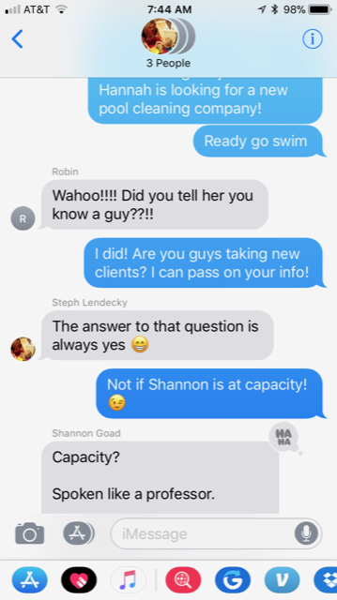

**Text 3 Text 4**

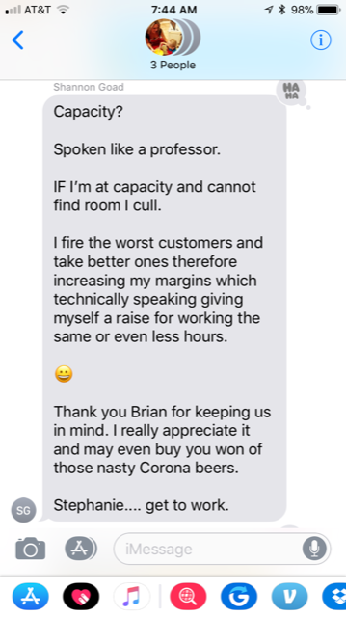 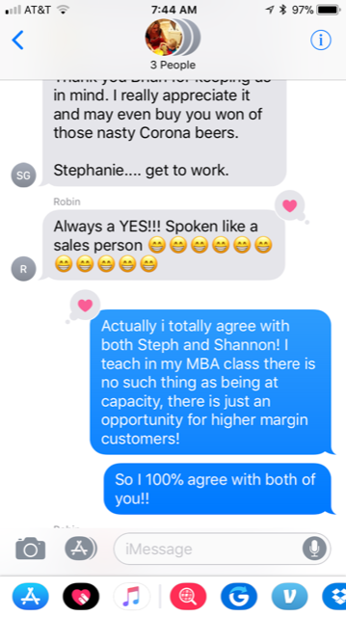

**Add or Drop a Service, Customer, Product, Department, Location, etc.**

It is January 1 and Day Street Deli’s owner, Avery Baker, is disturbed by the poor profit performance of his ice cream counter. Avery just had a meeting with his accountant and said he is going to close the ice cream counter. Day Street Deli’s accountant had correctly given Avery the following Ice Cream Counter Division Income Statement for the prior year ended December 31 earlier in the day:

Ice Cream Counter Sales $45,000

Less: COGS (milk, sugar, etc. - all variable) $20,000

Gross Margin $25,000

Less: Operating Expenses

Wages of ice cream counter personnel $12,000

Plastic products (plastic spoons for eating ice cream, etc.) $4,000

Utilities $2,900

Depreciation of counter equipment and furnishings $2,500

Depreciation of building $4,000

Accountant’s salary $3,000

Total operating expenses $28,400

Loss on ice cream counter <$3,400>

Some notes:

- The Utilities expense (which mostly consists of air conditioning for the building) for Day Street Deli is $11,600. Day Street Deli allocates 25% of utilities ($2,900) to the ice cream counter.

- Day Street Deli’s ice cream counter equipment and furnishings have no salvage value. In other words, Day Street Deli will just have to throw away the equipment and furnishings, nobody will give them any money for them.

- The depreciation of the entire building is $16,000. Day Street Deli allocates 25% of the depreciation ($4,000) to the ice cream counter.

- The accountant is a retired CPA and only works part time. Her yearly salary is $12,000. Day Street Deli allocates 25% of her salary ($3,000) to the ice cream counter.

- Avery is going to replace the ice cream counter with renting 4 vending machines which he estimates will earn him a positive cash flow of $750 a year *each*. (The overall utilities expense for Day Street Deli will be $11,600 whether there is an ice cream counter or vending machines.)

Based on just quantitative factors, is Avery making the right decision?

Keep Close

Sales from ice cream counter $45,000 $0

COGS from ice cream counter <$20,000> $0

Wages of ice cream counter personnel <$12,000> $0

Plastic products (plastic spoons for eating ice cream, etc.) <$4,000> $0

Vending Machines $0 $3,000

------------- ----------- $9,000 $3,000

Avery baker should keep the ice cream counter open because he will profit $6,000 more a year.

Which items in the income statement above (which is done correctly) are irrelevant when making this decision?

Utilities (doesn’t differ among alternatives), all depreciation (sunk cost therefore no bearing on the future and it doesn’t differ among alternatives), accountant’s salary (doesn’t differ among alternatives)

Qualitative factors to consider:

Is the product or service a “loss leader”?

Positive reputation or “credibility” the customer or business segment gives you.

**Outsource a product or service (aka make-or-buy decision)**

Marcus Reese is the Controller at Kallen Corporation. Kallen Corporation is under intense cost competition. Reese has been asked to evaluate whether Kallen Corporation should continue to manufacture MTR-20 or purchase it from Miville Company. Miville Company has submitted a bid to supply the 32,000 MTR-20 units that Kallen Corporation will need for the upcoming year at a price of $19.50 each. Kallen Corporation has capacity available to produce 32,000 units a year.

From plant records and interviews with Bryan Turnley, the plant manager, Marcuse Reese gathered the following information regarding Kallen Corporation’s costs to manufacture 32,000 units of MTR-20 last year:

Costs for 32,000 units last year

Direct materials $208,000

Direct manufacturing labor $128,000

Plant space rental $84,000

Equipment leasing (aka rental) $36,000

Other manufacturing overhead $230,000

Total manufacturing costs $686,000

None of Kallen Corporation’s Selling, General, and administrative costs will be affected by outsourcing MTR-20 to Miville Company.

Additionally, Turnley tells Reese that:

- Variable costs per unit this year will be the same as variable costs per unit last year.

- Plant rental and equipment lease are long-term contracts that are going to be expensive to wiggle out of. Turnley estimates it will cost $10,000 to terminate the plant rental contract and $5,000 to terminate the equipment lease contract.

- 40% of the other manufacturing overhead is variable.

- If MTR-20 is outsourced, 50% of the fixed component of other manufacturing overhead can be avoided.

Based solely on quantitative factors, should Marcus Reese recommend that MTR-20 be produced at Kallen Corporation or purchased from Miville Company?

How much money would be saved compared to the alternative?

What are some qualitative factors to consider when outsourcing?